Executive Board
Ryan M. McClure
Owner Ryno’s Fine Sports Collectibles

Larry Rolle
Senior Partner at Rolle Law

Debbie Babcock
Honorary Varsity I Recipient

Cam Wallace
President of Stan’s Sportsworld

Tom Scaggs
Scaggs Properties LLC

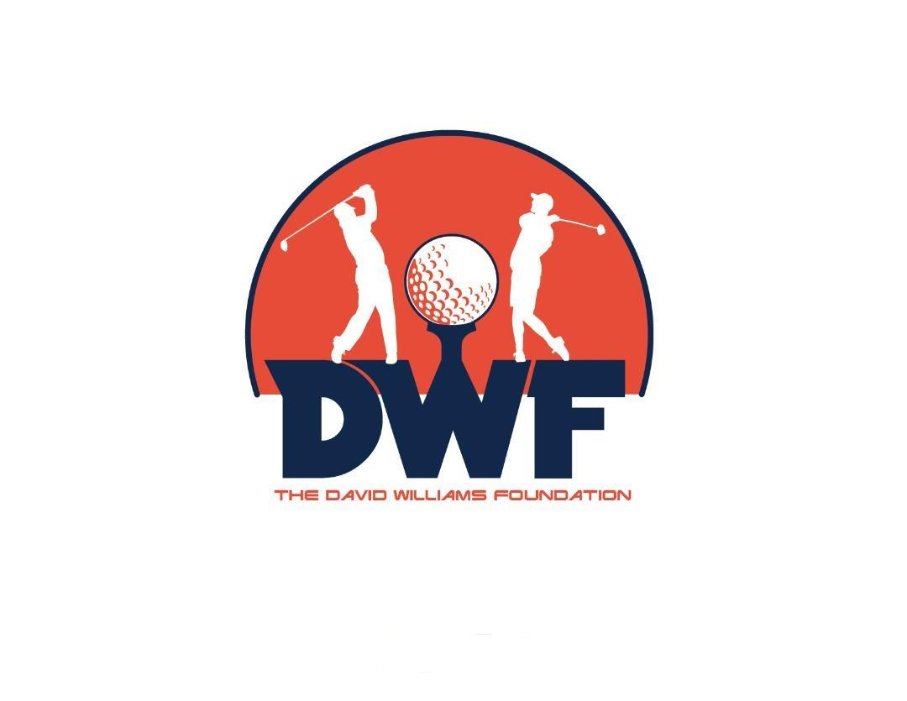

David Williams
President

2 x First Team All American at Illinois
College Football HOF
Canadian Football HOF
Illinois Athletics HOF

4 Man Scramble Golf Outing
June 8, 2024 at Savoy Orange Golf Course
REGISTRATION FORM
$150 per player
Hole Sponsorship with Foursome $75
Hole Sponsorship without Foursome $100
Make checks payable to: David Williams Foundation
DEADLINE: JUNE 5, 2024
For more information, please email Ryan McClure at Rynosfsc@gmail.com

Player 1 Player 2
Name: Name:
Phone #: Phone #:
Email: Email:
Shirt size: Shirt size:
Address: Address:

Player 3 Player 4
Name: Name:
Phone #: Phone #:
Email: Email:
Shirt size: Shirt size:
Address: Address:

Please send checks to:

Tom Scaggs
4212 Summer Field Rd.
Champaign, IL. 61822

